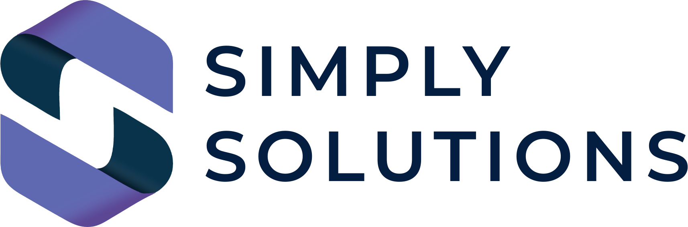

The Definitive South East London SME Cyber Security Audit 2026

Brought to you by Simply Solutions Enterprise Expertise for South East London SMEs | No Jargon. No Judgment. Just Solutions.

Overview
This audit is a comprehensive assessment based on the NCSC Small Business Guide, Cyber Essentials v3.3, and ISO 27001 principles, updated for the 2026 threat landscape.
How to use: Work through each section. Items marked with 🚩 are Critical Priorities—if these aren't checked, your business is at immediate risk.

1. Firewalls, Network & The "New Perimeter"
Your first line of defense against the outside world.
- [ ] 🚩 Active Hardware Firewall: A business-grade firewall is installed and active on your main internet gateway.
- [ ] 🚩 Password Security: All default administrative passwords on routers and firewalls have been changed to complex, unique strings.
- [ ] Documented Ruleset: All firewall "allow" and "deny" rules are documented and reviewed at least every 6 months.
- [ ] Disabled Remote Management: Remote administration of the router/firewall via the internet is disabled unless using a secure ZTNA/VPN.
- [ ] VLAN Segmentation: Your Guest Wi-Fi and IoT devices (smart bulbs, cameras) are on a separate network from your business data.
- [ ] Intrusion Prevention (IPS): Active scanning is enabled to block known malicious traffic patterns automatically.
- [ ] Inbound Port Audit: All unnecessary inbound ports (e.g., RDP Port 3389) are closed.

2. Secure Configuration & Hardware Hardening
Reducing the "attack surface" of your office devices.
- [ ] 🚩 Bloatware Removal: All unnecessary pre-installed software and "trialware" has been removed from new laptops and PCs.
- [ ] 🚩 Screen Lock Policy: All devices are configured to auto-lock after a maximum of 5 minutes of inactivity.
- [ ] Disabled Auto-Run: Auto-run and Auto-play features are disabled for all USB and external drives.
- [ ] BIOS/UEFI Passwords: Administrative passwords are set at the hardware level to prevent unauthorized booting from USBs.
- [ ] Approved Software Only: Users are restricted from installing unauthorized software without administrative approval.
- [ ] Hardware Inventory: A full asset register exists, tracking the serial number, user, and location of every company device.
- [ ] Secure Disposal: A formal process is in place for the cryptographic wiping of hard drives before recycling or selling old hardware.

3. Access Control & User Management
Ensuring the right people have the right access—and nothing more.
- [ ] 🚩 Unique Accounts: Every single staff member has their own unique login; sharing passwords or "Office Admin" accounts is strictly forbidden.
- [ ] 🚩 Standard User Rights: Daily work is performed on "Standard" accounts; "Administrator" accounts are used only for system changes.
- [ ] The 5-Minute Offboarding: A process exists to revoke all access (Email, CRM, Building) within 5 minutes of an employee's departure.
- [ ] Quarterly Privilege Review: Management reviews who has access to sensitive folders (HR, Finance) every 90 days.
- [ ] Just-In-Time (JIT) Access: Admin rights are only granted temporarily when needed, then automatically revoked.

4. Malware Protection & EDR (Endpoint Detection)
Defending against viruses, ransomware, and AI-driven malicious code.
- [ ] 🚩 Active Real-Time Scanning: Anti-malware software is active and scanning files in real-time on every device.
- [ ] 🚩 Daily Updates: Signature definitions update automatically at least once every 24 hours.
- [ ] Behavioral Analysis (EDR): Your security software looks for "strange behavior" (like 100 files being renamed at once) rather than just known viruses.
- [ ] Email Attachment Scanning: All incoming attachments are "sandboxed" (opened in a safe environment) before reaching the user.
- [ ] USB Lockdown: The use of unencrypted or unauthorized USB sticks is disabled across the company.
- [ ] Tamper Protection: Users are prevented from disabling or uninstalling security software without an admin code.

5. Software Updates & Patch Management
Closing the "open windows" in your software before hackers climb through.
- [ ] 🚩 The 14-Day Rule: All "Critical" and "High" security patches are applied to all devices within 14 days of release.
- [ ] 🚩 Unsupported Software Audit: No devices are running "End of Life" software (e.g., Windows 7/8, old versions of Office).
- [ ] Automated OS Updates: Windows, macOS, and Linux devices are set to download and install updates automatically.
- [ ] Third-Party App Patching: Non-Microsoft apps (Chrome, Adobe, Zoom) are included in the regular patching cycle.
- [ ] Firmware Updates: Router, Printer, and Switch firmware is checked and updated quarterly.

6. Data Backup, Recovery & Residency
Your ultimate insurance policy against total business failure.
- [ ] 🚩 The 3-2-1-1-0 Strategy:
  - [ ] 3 Copies of data
  - [ ] 2 Different media types
  - [ ] 1 Offsite copy
  - [ ] 1 Air-Gapped/Immutable copy (cannot be deleted/changed)
  - [ ] 0 Errors (verified daily)
- [ ] 🚩 Restoration Testing: A full data restore is successfully tested and documented at least every 6 months.
- [ ] Cloud-to-Cloud Backup: Your Microsoft 365 or Google Workspace data is backed up to a separate provider.
- [ ] Encryption at Rest: Backups are encrypted so that stolen backup drives or cloud accounts are useless to thieves.
- [ ] Data Residency Compliance: You have confirmed that sensitive client data is stored in UK-based data centers (or GDPR-compliant regions).

7. Password, Identity & Biometrics
Strengthening the weakest link in the security chain.
- [ ] 🚩 Multi-Factor Authentication (MFA): MFA is active on every cloud service, without exception.
- [ ] 🚩 Password Length: Your company policy requires a minimum of 12-14 characters for all passwords.
- [ ] Password Manager: Every staff member is provided with a secure password manager (e.g., Bitwarden, 1Password) to prevent password reuse.
- [ ] Passkey Adoption: High-risk accounts have migrated to Biometric Passkeys (FaceID/Fingerprint) or FIDO2 hardware keys.
- [ ] Account Lockout: Accounts are automatically locked for 30 minutes after 5 failed login attempts.

8. Email, Phishing & AI-Deepfake Defense
Email is the #1 attack vector for 90% of SME breaches.
- [ ] 🚩 Domain Authentication: SPF, DKIM, and DMARC are correctly configured for your email domain to prevent spoofing.
- [ ] 🚩 Deepfake Verification Protocol: A strict "verbal verification" policy is in place for any bank transfer or sensitive data request, regardless of "who" asks via email/voice note.
- [ ] Spam/Phishing Filtering: An advanced cloud filter is active to block malicious links before they reach the inbox.
- [ ] External Mail Flagging: All emails arriving from outside the organization are clearly marked with an [EXTERNAL] banner.
- [ ] Dangerous File Blocking: Files like .exe, .js, and .zip are blocked or heavily scrutinized by the email gateway.

9. Physical, Device & PSTN Security
Securing the tangible assets of your South East London office.
- [ ] 🚩 Full-Disk Encryption (BitLocker/FileVault): All laptops are encrypted so that data is unreadable if the device is stolen.
- [ ] 🚩 Remote Wipe: You have the ability to "nuke" any lost or stolen device remotely via MDM (Mobile Device Management).
- [ ] PSTN/ISDN Audit: All legacy hardware (Alarms, Elevator phones, Fax machines) has been identified for the 2027 PSTN switch-off.
- [ ] Secure Hardware Storage: Servers and network switches are kept in a locked room or rack with restricted access.
- [ ] CCTV & Physical Alarms: The physical office is secured with monitored alarms and clear CCTV coverage.

10. Staff Awareness & AI Governance
Building a culture of security.
- [ ] 🚩 Induction Training: Every new hire receives 30 minutes of cyber security training before receiving their login details.
- [ ] Annual Refresher: All staff undergo formal security awareness training at least once a year.
- [ ] AI Acceptable Use Policy: A signed document exists stating which company data is strictly forbidden from being put into public AI tools.
- [ ] Simulated Phishing: The company conducts "friendly" phishing tests twice a year to identify staff who need extra training.
- [ ] Incident Reporting: Every employee knows exactly who to call (and how) the moment they think they've clicked a bad link.

📈 Your Resilience Score
Total Items Checked: ________ / 72
Critical (🚩) Items Checked: ________ / 22
Score | Rating | Action Required
60-72 | Excellent | You are "Cyber Essentials Plus" ready. Maintain and document.
45-59 | Good | Solid foundations, but you have gaps that professional hackers will exploit.
30-44 | Vulnerable | You have significant weaknesses. Prioritize all 🚩 items immediately.
Under 30 | Critical Risk | Your business is statistically likely to suffer a breach within 12 months.

🆘 Need an Expert Review?
Simply Solutions brings 30 years of Silver Circle expertise to your high street. We don't just find the gaps; we close them.
Contact the Simply Solutions Team:
📍 Serving Bromley, Greenwich, Lewisham & Beyond
🌐 simplysolutions.tech
✉️ info@simplysolutions.tech
No jargon. No judgment. Just solutions.

