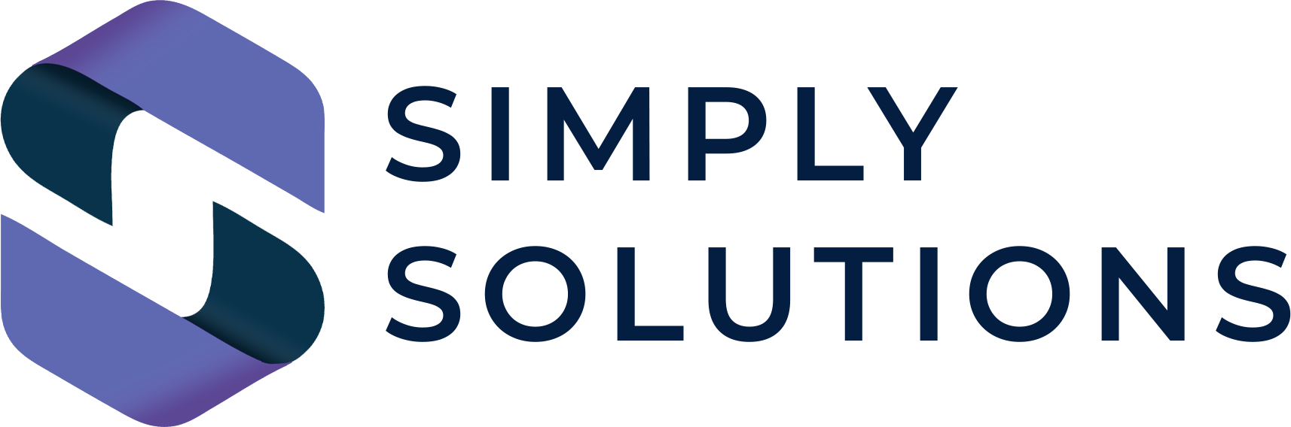

The SME Artificial Intelligence Strategy & Governance Master Plan (2026 Edition)

Brought to you by Simply Solutions Enterprise-Grade Governance for Small Business | No Jargon. No Judgment. Just Solutions.

Executive Strategic Overview
In 2026, Artificial Intelligence is no longer a "plugin"—it is the engine of modern business. However, for most SMEs in South East London, "Shadow AI" (employees using unmanaged tools) represents a catastrophic risk to data privacy, professional liability, and brand reputation.
This Master Plan is designed to move your business from "unregulated usage" to "strategic excellence."
How to use: This is an exhaustive framework. Review each section, populate the specific tool lists in Section 3, and implement the "Human-in-the-Loop" (HITL) requirements in Section 5.

1. Core Philosophy: The "Responsible AI" Principles
Setting the ethical and operational baseline for your organization.
- Transparency: We will always be open with our clients in Bromley, Greenwich, and beyond about when and how AI is used in our deliverables.
- Accountability: AI is a tool, not an employee. A human remains 100% responsible for every output, email, and decision influenced by AI.
- Privacy-First: We prioritize the protection of client Personal Identifiable Information (PII) above all productivity gains.
- No Bias: We actively audit AI outputs to ensure they do not reflect or amplify societal biases.

2. Data Classification & The "Billboard" Rule
Defining exactly what can and cannot be fed into an AI model.
🚩 THE GOLDEN RULE: Never input data into a public AI tool that you would not be comfortable posting on a public billboard in the middle of Bromley High Street.
- 🟢 Level 1: Public Domain Data
  - Includes: Public marketing copy, generic industry news, public event details.
  - AI Usage: Fully Permitted for summarizing, tone-shifting, and brainstorming.
- 🟡 Level 2: Internal Business Data
  - Includes: Internal handbooks, non-sensitive memos, generic process documents.
  - AI Usage: Restricted. Requires use of "Enterprise-Wrapped" tools only (No personal accounts).
- 🔴 Level 3: Highly Sensitive / Protected Data
  - Includes: Client PII, Bank details, Legal strategies, Intellectual Property, Trade secrets, Medical records.
  - AI Usage: STRICTLY PROHIBITED unless using a dedicated, air-gapped, or "Zero-Training" Enterprise instance approved by Simply Solutions.

3. The Approved "Tech Stack" (2026 Audit)
Staff are strictly forbidden from using any AI tool not listed below.
Tool Category | Approved Platform | Usage Condition
General LLM | e.g., Microsoft 365 Copilot | Must use Company Login (Enterprise)
Research/Analysis | e.g., Perplexity Enterprise | No client PII allowed in queries
Creative/Design | e.g., Adobe Firefly | Commercial use license only
Coding/Dev | e.g., GitHub Copilot | Prohibited for core security modules

4. Prompt Engineering & "Injection" Security
Preventing the accidental leak of data through "Prompt Leaks."
- [ ] Zero-Training Toggle: Ensure that "Use data for training" is turned OFF in all admin settings.
- [ ] Anonymization Protocol: All prompts must be stripped of specific names, addresses, or identifiers before being submitted.
- [ ] Prompt Injection Defense: Staff are trained to recognize "Jailbreak" prompts that might try to force an AI to reveal internal company instructions.
- [ ] No "Copy-Paste" of Full Files: Staff are prohibited from uploading full CSVs or sensitive PDFs to public AI "Chat with your PDF" tools.

5. Quality Control: The "Human-in-the-Loop" (HITL) Mandate
AI-generated content is a draft, never a final product.
- The Hallucination Check: Every fact, statistic, or legal citation generated by AI must be cross-referenced with a primary source.
- The Tone Check: AI tends to sound "robotic" or overly formal. Staff must edit for the "Simply Solutions" human voice.
- The "Sign-Off" Requirement: All AI-assisted client reports must be signed off by a Senior Manager who has reviewed the AI-to-Human ratio of the work.

6. Prohibited Use Cases (The "Red Lines")
Under no circumstances shall AI be used for:
- 🚩 Performance Reviews: AI must not be the primary tool for grading staff or making hiring/firing decisions.
- 🚩 Unsupervised Legal/Contractual Work: Generating binding contracts without qualified legal review.
- 🚩 Automatic Email Replies: Setting up "Auto-Bots" that talk directly to clients without a human gatekeeper.
- 🚩 Security Bypassing: Attempting to use AI to "crack" or probe the company's own network vulnerabilities.

7. Deepfake & Social Engineering Defense
In 2026, "Verification" is the only defense against AI-driven fraud.
- Voice Verification: If a Director or Client requests a bank transfer via a "Voice Note" or phone call, staff must call them back on a verified number.
- The "Safe Word" Protocol: High-stakes departments (Finance/Operations) must use a pre-arranged, non-digital safe word to verify identity in emergency scenarios.
- Video Authentication: Be wary of unusual video calls. If a caller's movement seems "laggy" or their features "glitch," treat it as a Deepfake attempt.

8. Vendor & Supply Chain Governance
Your security is only as strong as the AI your partners use.
- Third-Party Audit: We require all key vendors (Accountants, Web Designers, HR) to provide their own AI usage policy.
- API Security: If we integrate AI into our website or CRM, Simply Solutions must perform a monthly API security audit.

9. Staff Acknowledgment & Training
I, [Employee Name], acknowledge that I have read the Simply Solutions AI Strategy & Governance Master Plan. I understand that my usage of AI will be monitored for compliance and that data leaks caused by negligence may result in disciplinary action.
Signed: __________________________
Date: ____________________________

10. The AI Maturity Scale: Where Do You Sit?
Stage | Description | Action
Level 1: Chaotic | Staff use free ChatGPT accounts; no oversight. | CRITICAL RISK - Contact us today.
Level 2: Reactive | Some policies exist, but usage is inconsistent. | Implementation of this Master Plan.
Level 3: Governed | Enterprise tools are in place; staff are trained. | Quarterly strategy reviews.
Level 4: Optimized | AI is driving 20%+ ROI with zero data leaks. | This is the Simply Solutions Gold Standard.

🆘 Need a Fractional CTO to Lead Your AI Transition?
Implementing AI safely requires more than a PDF; it requires a strategic partner. We can help you deploy Microsoft 365 Copilot, secure your data, and train your team.
Contact the Simply Solutions Team:
📍 Serving Bromley, Greenwich, Lewisham & Beyond
🌐 simplysolutions.tech
✉️ info@simplysolutions.tech
No jargon. No judgment. Just solutions.

